Requoting & Submitting Changes to American Mutual

1. From the main screen of APPS Online select Search for Policies.

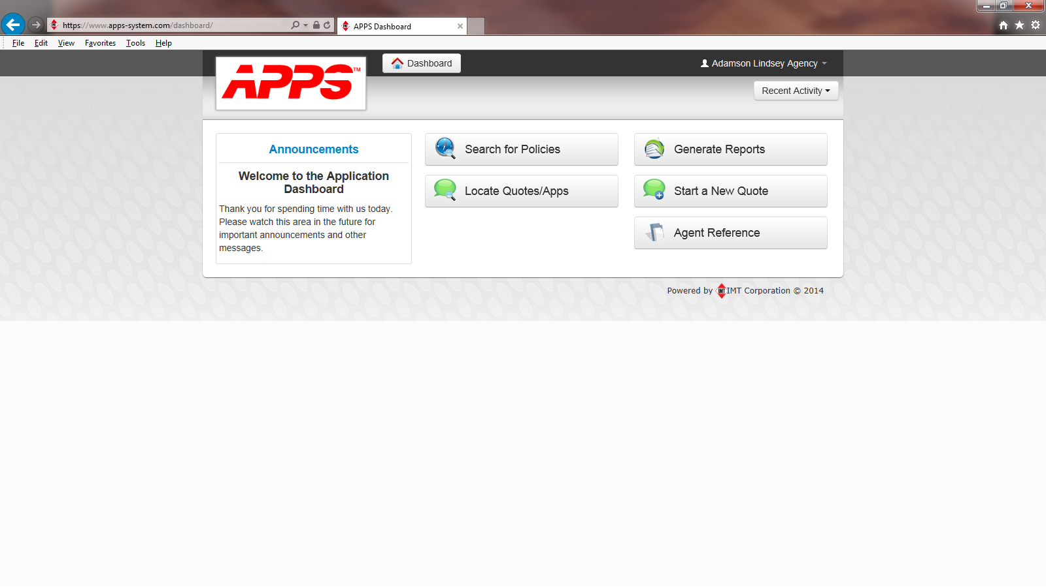

Copy to Quote

1. Once you are at the main screen of the policy, be sure to select the correct effective date before selecting copy to quote. If the has not renewed yet on the day you run the quote, but the renewal has been ran, you can either select the current period or the renewal period to quote. Once you click on Copy to Quote you will get a message the quote has been created with a link to the quote.

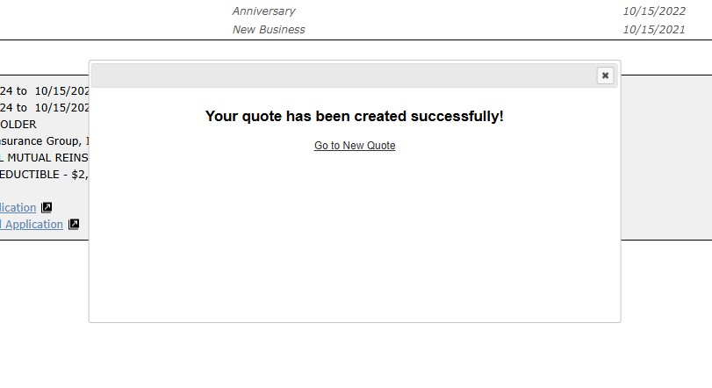

1. Once you go to the quote you want to check a couple of things:
   1. You can rename the quote from “Copy of XXXXXX” to whatever you want so it is easier to find later.
   2. Check to make sure the effective date is right. Pricing is set based on the effective date of the renewal so if you are quoting a mid-term change it should match the effective date of the renewal period.
   3. You will notice the Reports Tab is red. The system does not recognize that Financial Stability may already be on the policy. Simple send a message using the Comments Button to ask to have the credit overwritten to its current level.
   4. PLEASE NOTE: if you run the credit again and it is different than what is on the policy, your quote will not be accurate. If it is better than what is currently on the policy (level 1 is the best and level 7 the worst), you need to submit a change to update the financial stability. We only allow it to be re-ran once per renewal. If it is worse, please message us using the Comment Button to overwrite its current level.
   5. Once these items are complete you can proceed with your quote.

Submitting a Change Request

1. Search for the customer you wish to requote or make a change on and press “Search”. Please note if you do not enter anything in the name or policy number fields and just press “Search” all of the policies for the agency will appear. You will notice that if there are two people on the policy, depending on how you did the search, the policy number may appear more than once as shown below. Just select the “Policy Number” you want to make a change on or requote.

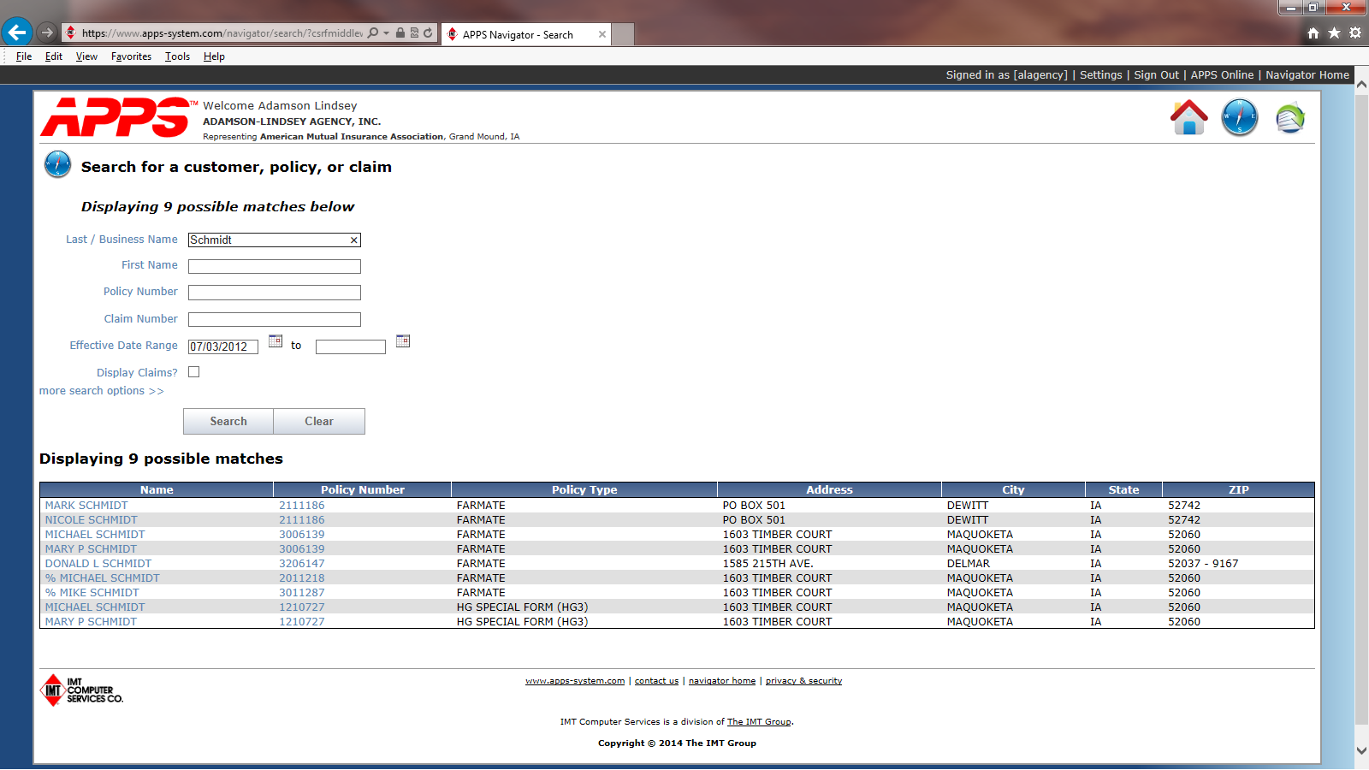

1. From the main screen of the policy you will see in the lower right hand corner a Copy to Quote, Change Request or Submit New Claim Button.

1. In the Change form it will generate the form below. Simply select the “Effective Date” of the change and type in the changes required.

1. Once you have the change ready you can send the request, in which case an email will be generated and sent to info@amutualins.com and the person submitting the request. **Please note that American Mutual does not require signed changes unless you are cancelling a policy or removing an insured from a policy. We will also accept a signed ACORD Cancellation as well, which you can attach under Other Attachments.**

You can also attach a Blanket Inventory, pictures, or a signed endorsement if needed under “Other Attachments”.

